**Lab 01 – Part 2**

**Objectives:**

1. Login to MySQL Server
2. Create the College database
3. Exploring the College database

**Tasks:**

**Create Database:**

Login to MySQL server using your MySQL username and password. If this your first time connecting to MySQL server, you need to create a new connection.

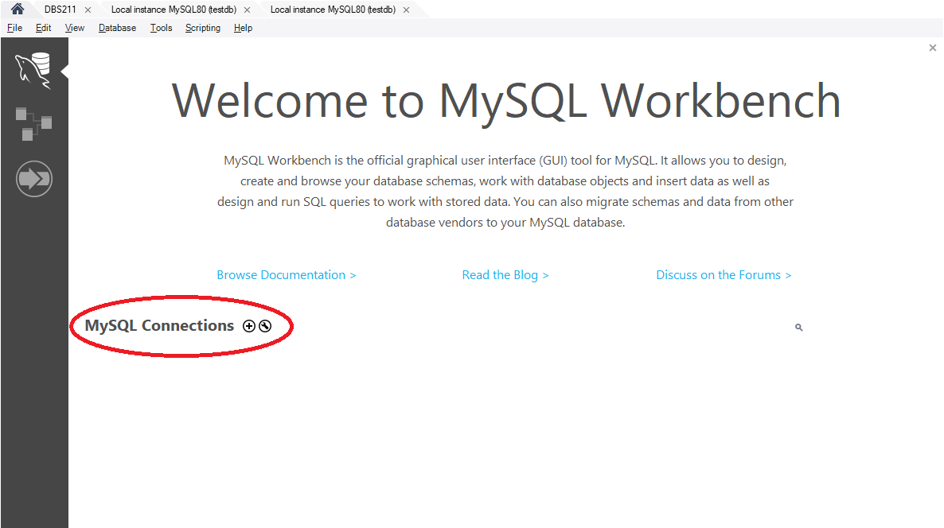

To set up a new connection, provide the hostname and the username.

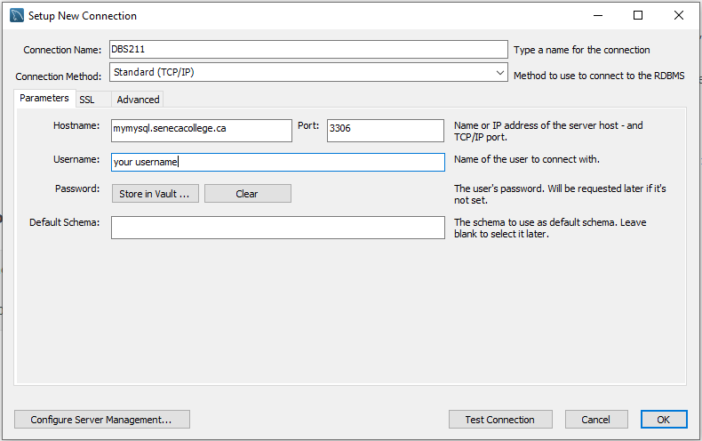

You will be asked to enter the password when you want to connect to the server.

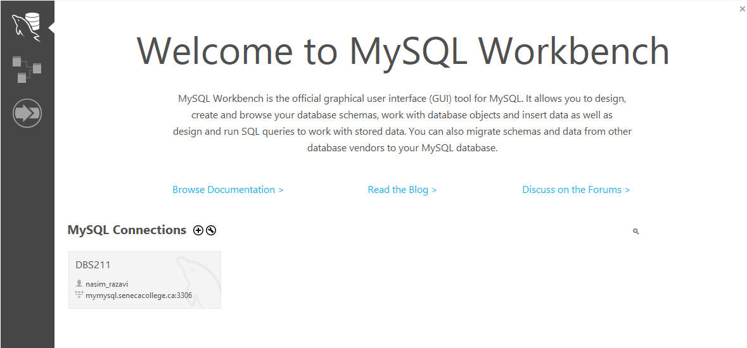

Choose the connection you have created and enter the password.

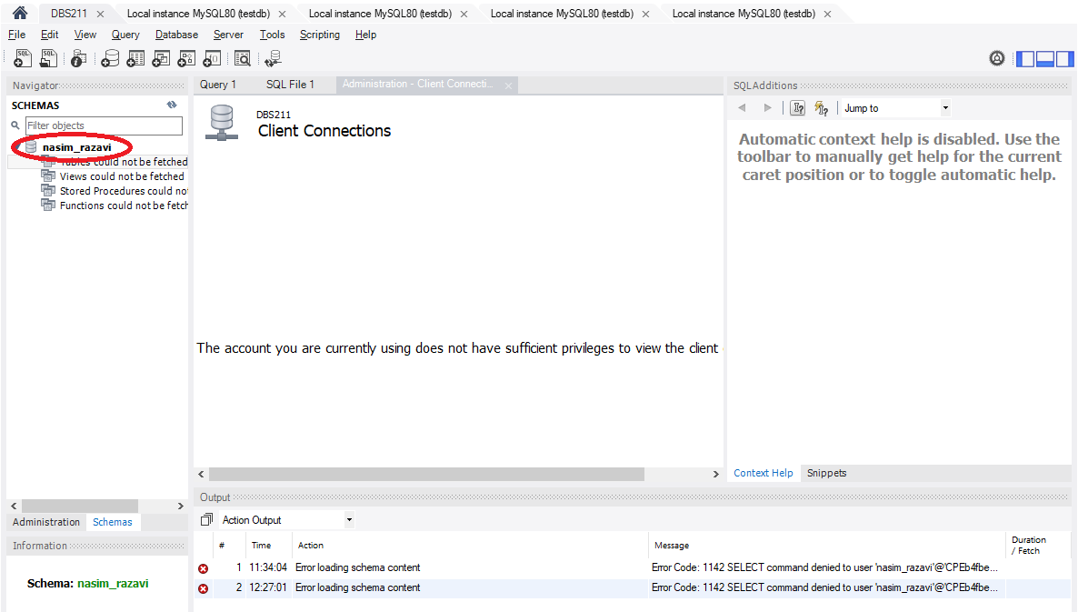

The name of your schema (database) on the Seneca server is the same as your username. Next, you need to create a database and its tables. Execute the provided SQL script. To open and execute these scripts, from the **File** menu, choose the **Open SQL Script**.

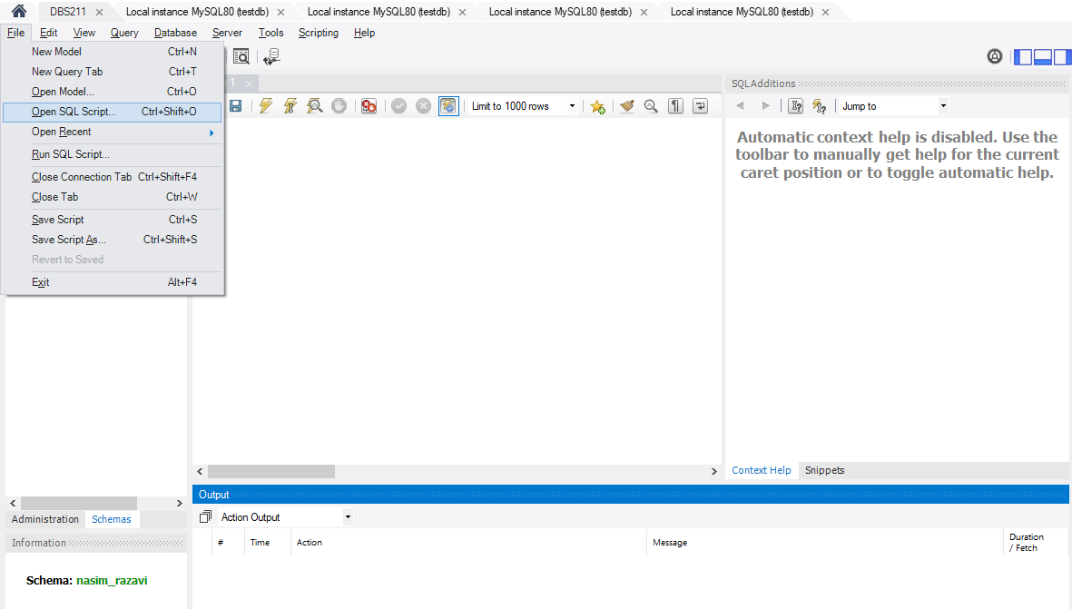

Open the folder containing the scripts and select the database-creation.sql script to be opened.

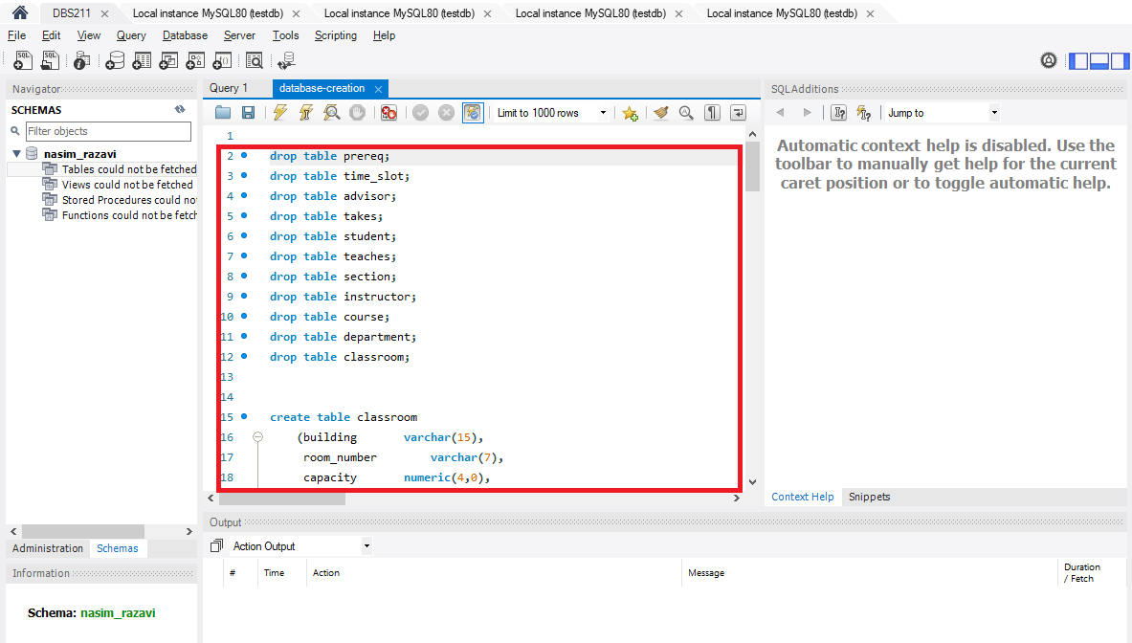

All SQL statements will be loaded into the query tab. To execute the script, press the execution button (specified with a green circle) to execute the all statements.

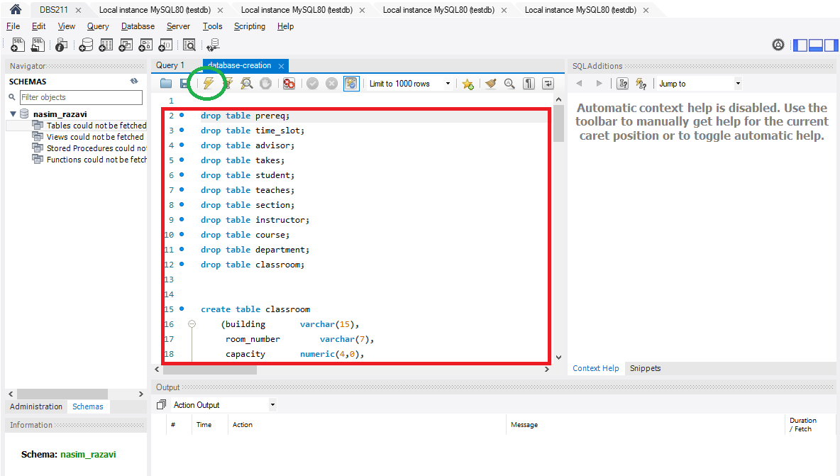

If there is any error, you can see them in the output panel. If there is no error you could successfully create the database tables.

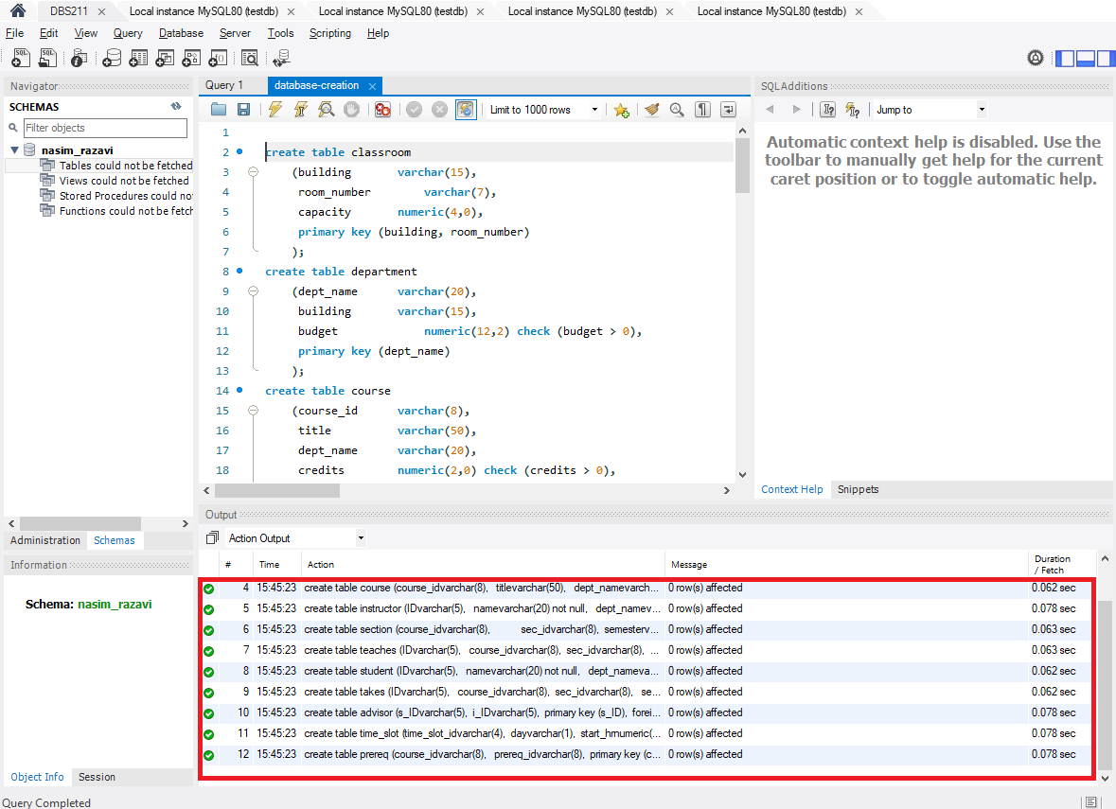

Take the same steps to load and execute the data-insertion.sql script to insert data in to your tables. Make sure the script is executed successfully with no error.

**Explore the Database**

In the object browser, expand **Tables.**

1. How many tables have been created? List the name of created tables.

In total 08 tables have been created which are:

Customers

Employees

Offices

Orderdetails

Order

Payment

Productlines

products

1. Right click on table **customers**. Select the first option **Select Rows – Limit 1000**.

How many rows are selected from table **customers**?

122 rows are selected.

1. What SQL statement is executed in the SQL tab after selecting **Select Rows – Limit 1000**. Write the statement in the space provided below.

SELECT * FROM `db_skamdem-kamguia`.customers;

You will learn how to select rows and columns from a table by writing SQL select statements later in this course.

1. How many columns does the **customers** table have? List the column names.

The customers table have 13 columns which are:

customerNumber

custumerName

contactLastName

contactFirstName

phone

addressLine1

addressLine2

city

state

postalCode

country

salesRepEmployeeNumber

creditLimit

1. What is the value of each column in the first row in table **customers**? Write the column name and the column value.

customerNumber: 103

custumerName: Atelier graphique

contactLastName: Schmitt

contactFirstName: Carine

phone: 40.32.2555

addressLine1: 54, rueRoyale

addressLine2: NULL

city: Nantes

state: NULL

postalCode: 44000

country: France

salesRepEmployeeNumber: 1370

creditLimit: 21000.00

1. Write the number of rows and columns for the rest of the tables in your schema.

Table Name Rows Columns

Employees 23 8

Offices 7 9

Orderdetails 1000 5

Order 326 7

Payment 273 4

Productlines 7 4

Products 110 9

1. Right click on table **employees**. Select **Alter Table**. In the column subtab, you can see the list of columns and edit them. Do not modify any column.

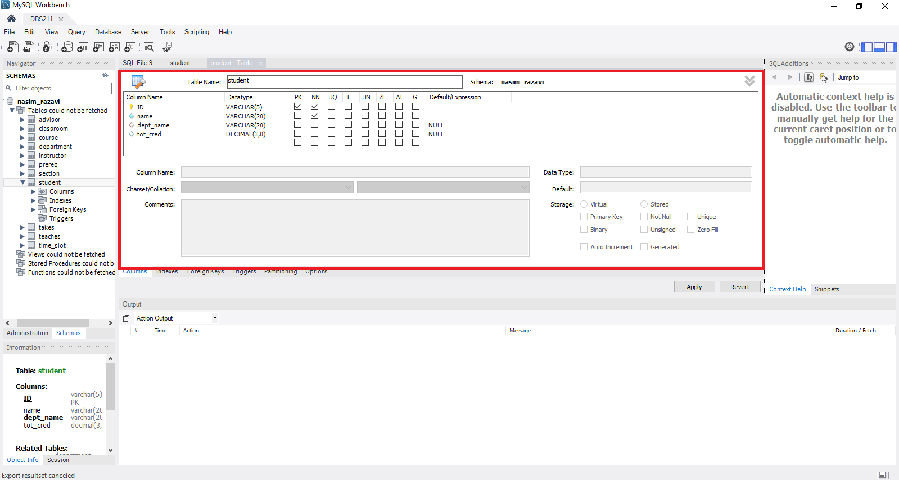

List the column names and types for table **employees**.

Column Name Column Type

emplyeeNumber INT

lastName VARCHAR

fitstName VARCHAR

extension VARCHAR

email VARCHAR

officeCoded VARCHAR

reportsTo INT

job Title VARCHAR

1. Open a new SQL tab.

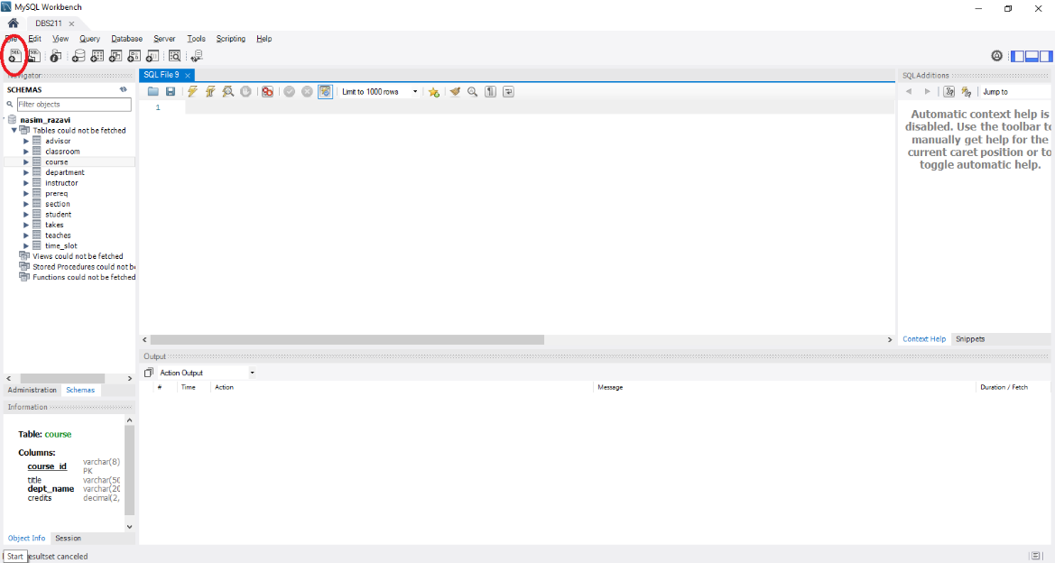

Write the following SQL statement in the new tab.

desc offices;

You can also write

describe offices;

Select the run button to execute the statement. See the next image for the execution button.

What is the result of the statement execution?

It provides information about the column name officeCode such as type,field, Null, key ,default,extra.

